A Digital Prescription Android App for Interface between Doctor and Patient

Vivek Rugale, Prashant Rathod, Pratik Sathwane, Praveen Pol

Department of Instrumentation and Control Engineering

Vishwakarma Institute of Technology, Pune

*Abstract*—This paper presents an android application for consulting doctor by making a interface between doctor and patient. This app was proposed to develop an interaction between doctor and patient and so the patient takes medicines on time. Platform used to build this application is android studio. A patient can choose among the registered doctors on this app. The doctor can prescribe medicines digitally through the app for the patients registered under particular doctor. The purpose of the project is to provide a convenient platform for the patients so that medicines timing will not be confused.

Keywords— Registration, Login, Android, Database, Prescription

# Introduction

The number of confirmed cases as well as deaths caused by the novel coronavirus disease COVID-19 have continued to surge across the world. The World Health Organization (WHO) has declared Covid-19 as a pandemic due to the increase in the number of cases reported around the world. However, as per a study conducted by scroll.in more than 5 lakhs deaths could have been prevented across India if they were treated or consulted to doctor and have taken proper medicine. This is a data of early lockdown non-covidal deaths. So a consultant app can be the most effective tool when doctors aren’t much checking patient that closely due to spreading pandemic as the world still waits for an effective treatment.[1]

To implement social distancing, group activities and congregations such as travel, meetings, gatherings, workshops, praying had been banned during the quarantine period. The people are encouraged to use phone and email to manage and conduct events as much as possible to minimize the person-to-person contact. To further contain the spread of the virus, people are also informed to perform hygiene measures such as frequently washing hands, wearing mask and avoiding close contact with people who are ill. But not only in covid period but even on normal days in busy schedule sometimes we forget to take medicines on time.

However, there is a difference between knowing the timings of medicines and taking them on time. In fact, it has been observed that there are many people who ignore timing or cannot remember the timings in their busy lifestyle.

Hence, this project aims to facilitate the enforcement of taking the referred medicines on time. An alarm triggers the brain to take the medicines on time. When we listen alarm it is more effective probability we will take medicines although being in busy schedule.

# related work

This section highlights some of the related works about doctors and patient. The doctor patient ratio in India is 1:1456 which is much less than the recommended 1:1000.[2] It discusses different methods proposed earlier to solve this problem and the approach used in them.

This apps helps patients to maintain their health with help of doctors. Kareo is also one of app available for iOS which uses cloud. It also has insurance cover providers and services related to it. But it is a paid app which one has to pay monthly per user. One can also send photos to consultant physician.

Another one is for android, which has its data trained, so the app gives the recommendation to what question you are asking what it is related to. One can give answers with references.

My care is one app, which works on location basis and shows medical practitioners nearby. Whom one can contact on preference and their field of expertise. Chat window helps in interaction with doctor. In addition, it can provide an advantage that if any one has any psychiatric problem and there is some issue with to move to doctor or one may be introvert so it will be have an edge over here. Also, it is available in various languages.

.

# methodology

This tool is developed to for social welfare purpose as to help maximum people which it can reach. Therefore, it can run on many of android phones.

This app is developed using android studio platform and programmed in Java. Google firebase is used as database for storing data online. After users registering themselves as patients they have option to get registered under the doctor they want out of registered doctors in the app. The following block diagram shows the overall architecture of the app -

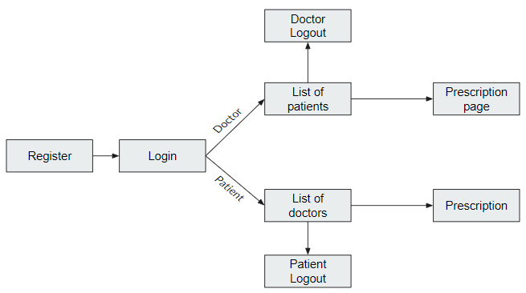

After the detection of the registered user , it automatically switches to the window depending on user type i.e. weather he/she is patient or doctor. And the further window. The app consists of 6 activities/pages.

# DESIGN

## Registration Page

Any user want to use this app has register first. It is very simple and user friendly. Here one have to enter one’s details Name , email ID , password , contact number and then register. Register page also features an option button to register user as doctor or patient.

Once the registration is done user can login anytime ,anywhere whenever is the need and necessity.

## Database Management

Firebase is a platform of google which provides the access to store data, use change and delete whenever needed. It is an open source platform. Our data of login credentials of patients and doctors, medicines info is stored here.

The workflow steps for using data in firebase server used is as follows:

1. Taking input from user
2. Creating a firebase server
3. Declaring the path to save required data in particular server
4. Upload

The user details are stored in database in a very systematic manner considering user privacy. Patients are stored under a chosen doctor node as childs in a tree data structure. The respective medicine prescription for a particular patient is stored as a child under patient as node. So that the path for uploading patient info and medicines info is well managed. Following image shows a example tree data structure of data storage in firebase –

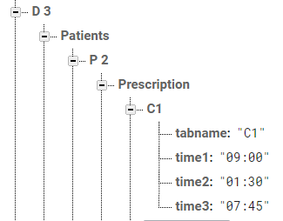

## Notification

The ultimate goal of the project is to push a notification on time of medicine. Once we know the medicines prescribed and the time then it is easy to notify for that medicine for particular time.

# results

As we install the app in phone, we can register as doctor or a patient. And then the interface varies for doctor and for patients. Patients sees the medicines prescribed by doctor, doctors sees the list of patients, and the medicines prescribed. Following are some screenshots from the app -

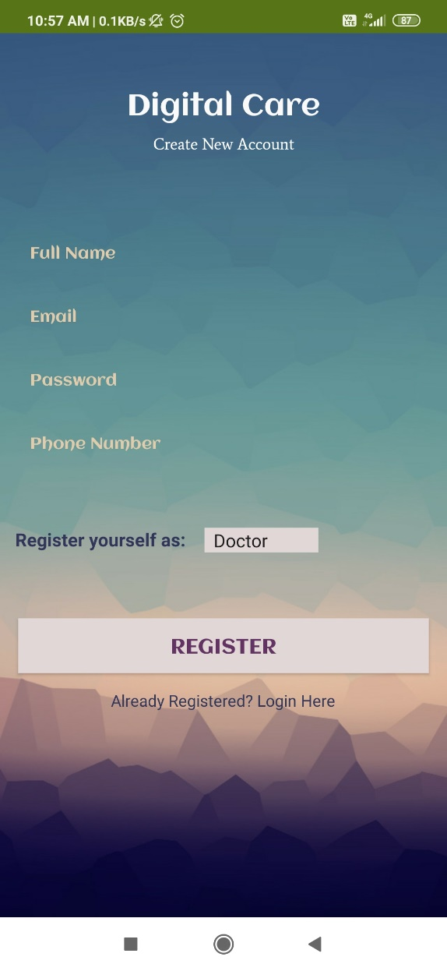

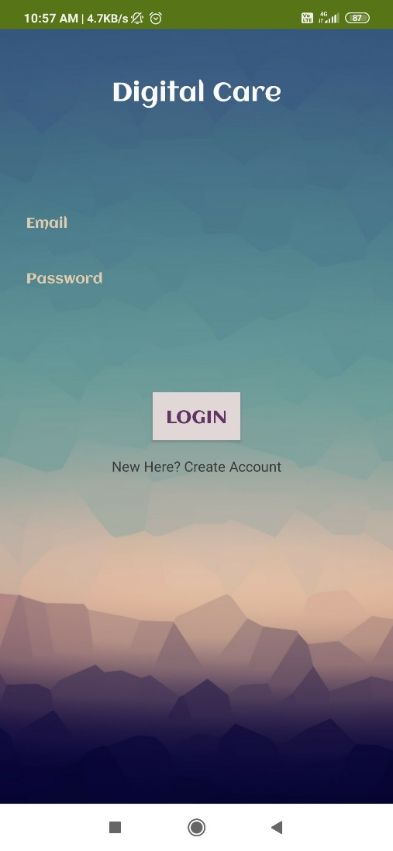 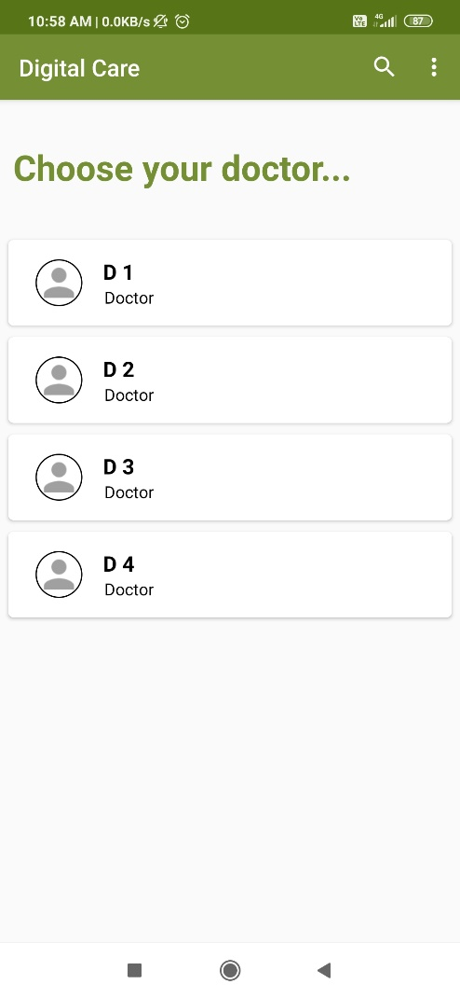 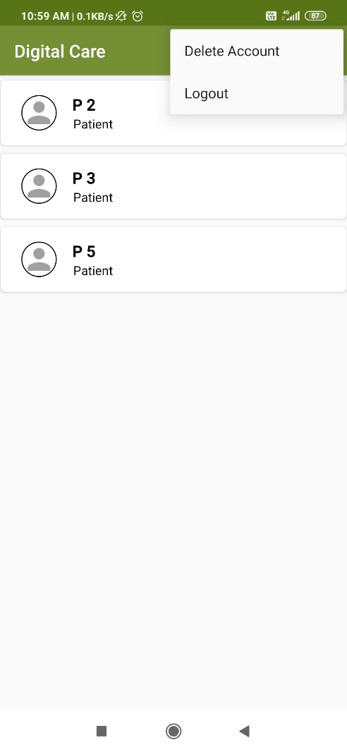

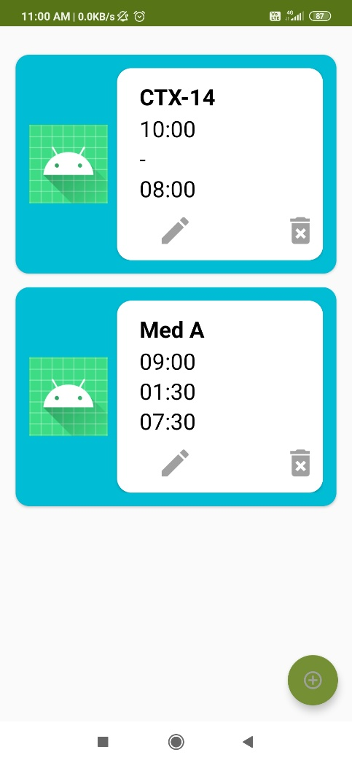

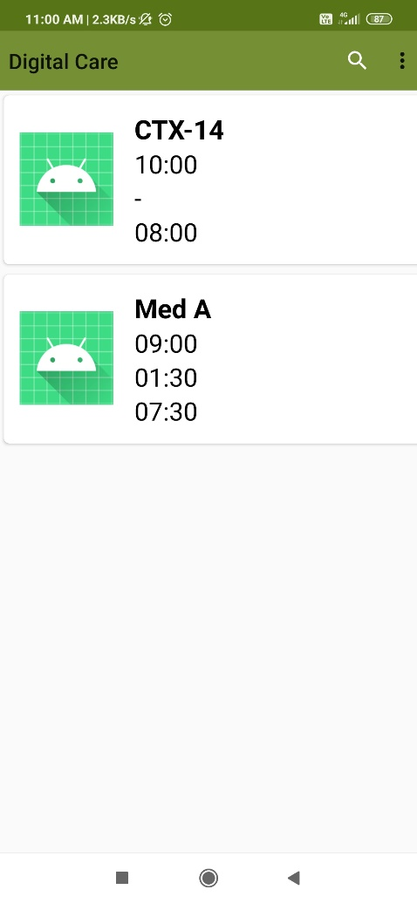

Further, about the user interface is kept far simpler, than to go for fancy so that aged people can also be friendly and easy to use.

# conclusion and future works

This project provides a very useful and convenient platform for doctor and patient interface. The purpose of this app is to remind patient every time a medicine time triggers. Our project does not validate if anyone registering as doctor has a valid degree. It assumes that entered information is correct. This app will always have brighter future with more useful updates. In future, a validating feature can be added. And a feature to locate the nearest medicine shops or ordering online medicines can be added. There is no limit for future scope ideas which will make app more creative.

Although this UI is very catchy, user friendly and easy. People can use in environment such as home, office, etc. This app can be installed in our daily smart phones with android version 4.4 and more.

##### References

1. Stronger health system could have averted 500,000 non-covid deaths in India in early lockdown period . Available at https://scroll.in/article/962147/stronger-health-system-could-have-averted-500000-non-covid-deaths-in-india-in-early-lockdown-period
2. Madhav Deo., “Doctor population ratio in India,” The Indian journal of Medical Reseach, April 2013.
3. The doctor-population ratio in India is 1:1456 against WHO recommendation at : https://www.deccanherald.com/business/budget-2020/the-doctor-population-ratio-in-india-is-11456-against-who-recommendation-800034.html.